
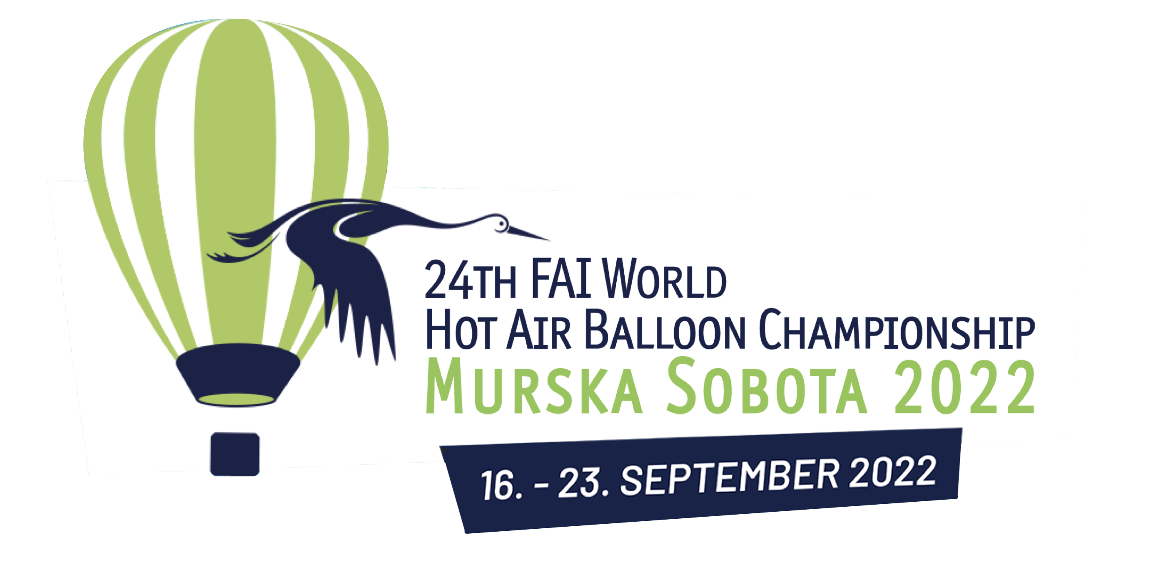

PRESS RELEASE

Murska Sobota to host the best hot air balloon pilots at the World Championship

Ljubljana, June 23, 2022 – This year, between September 16 and 23, Slovenia and Murska Sobota will host the biggest air sports event, the World Hot Air Balloon Championship, where more than 150 balloons will be admired in the air. 105 ballooning teams from 33 countries will compete over six days of competition, and a rich accompanying programme is being prepared for visitors; there will also be balloons available for anyone who wants to fly.

Murska Sobota will host this year's world's top aviation event from 16 to 23 September: the World Hot Air Ballooning Championships, which was postponed for two years due to the pandemic. The competition is organised by the local ROTO Balloon Club in cooperation with its partners FAI – the World Air Sports Federation, the Municipality of Murska Sobota, the Aeronautical Association of Slovenia and the Aeroclub Murska Sobota. Presentation film>>

The Pomurje region is ideal for ballooning due to its flat terrain and favourabe temperatures and winds. Pomurje has already hosted the European Hot Air Balloon Championship in 1994. The then competing teams still remember it fondly for its excellent organisation, beautiful scenery and the hospitality of the local people.
In 2019, the Pre-World Championship, or the Slovenian Open National Hot Air Balloon Championship was held in the same organisation as this year, with 40 local and foreign teams from Slovenia and 18 foreign countries. The Pre-World Championship was a kind of rehearsal for the World Championship, and the organisers did an excellent job. In 2020, despite the measures taken against the pandemic, they managed to organise the Open National Championship, and for the first time in the history of Slovenia, we were able to witness the take-off of gas balloons from the Expano Pavilion at the Lake Soboško jezero.

The coming event is a great recognition for Slovenian ballooning and a very responsible task for the organising committee. The World Hot Air Balloon Championship Murska Sobota 2022 will be even more challenging in terms of organisation, with 800 members of competing teams alone.

The World Championship will bring together competing teams from all over the world. We will be able to admire more than 150 balloons in the air, mainly taking off and landing at Murska Sobota Airport; the main centre for the competitors will be at the Rakičan Castle, while the opening ceremony and accompanying activities will take place at the Expano venue. For 12 days, we will host 105 ballooning teams from 33 countries, who will compete in various tasks over the six days of competition, showing their balloon handling skills and skills in solving various tasks.

The competition is conducted in accordance with the standard rules of theFAI, which define the tasks in which the pilots compete and the rules on the basis of which the winning pilot is selected at the end of the competition. Two flights are planned each day, and each flight may contain several different tasks, which are defined before the flight starts, when the weather conditions are known. The aim of competition flights is not to achieve the best time, distance,or altitude as in other sports. Competitions require pilots to use their skills to control balloons over a specific area. Tasks include targets, objectives, scoring areas, time and space constraints that the pilot must observe to demonstrate his/her ability to plan, anticipate and manage the balloon in the given weather conditions. The competition is essentially a strategy game in which the competitors combine several components, requiring considerable tactical skills.

Slovenia has a number of excellent hot air balloon pilots who have achieved outstanding results in international competitions, including in the first category of FAI events. This year, Vito Rome, Dejan Buzeti, and Jernej Bojanovič qualified for the World Championship. We will also host the current World Champion, Dominic Bareford, the reigning women's world champion Daria Dudkiewicz-Golawska and two junior world champions Roy Gommer and Jan Suchy.

It will not only be an event for the top competitors, but a ballooning spectacle. The multitude of colourful balloons in the air is definitely a feast for the eyes, and will surely attract to Pomurje a lot of hot air balloon enthusiasts from Slovenia and abroad. This type of sports competition is also an attraction, together with the Expano exhibition pavilion and many other things that the region can offer tourists.
This year, the organisers are preparing a rich accompanying programme for the general public. At the opening event on September 17, where up to 10,000 people are expected, the main attraction will be the aeronautical rally EXPANO AEROSHOW and KEY GRAB, an attractive discipline in which balloons compete to see who will be the first to pick up a key in the middle of the Lake Soboško jezero. Among the most photogenic moments will surely be the evening group take-offs (FLY-OUT) and morning group arrivals (FLY-IN) of more than 100 balloons in the surroundings of the Murska Sobota Airport, and the NIGHT GLOW, where 40 festival balloons of all colours and shapes will shine in a special glow.

The most eagerly awaited novelty of this year's event is the commercial flights – 100 places on the morning and 100 places on the evening flights will be available every day of the Championships for visitors to fly in a hot air balloon and get a bird's-eye view of the venue. Booking and tickets for the flights will be available next week on the organiser's website. So come to Murska Sobota to meet new champions and experience this unique sport up close.

PHOTO AND VIDEO MATERIAL can be found here:

https://drive.google.com/drive/folders/1GK6qzAzgkKJlm5dNsYT4X39KY11CdlsT?usp=sharing
- Presentation film and presentation of HAB2022
- Photos from the press conference (author Nina Lepoša)
- Photos from the 2019 Pre-World Championship and 2020 National Championship

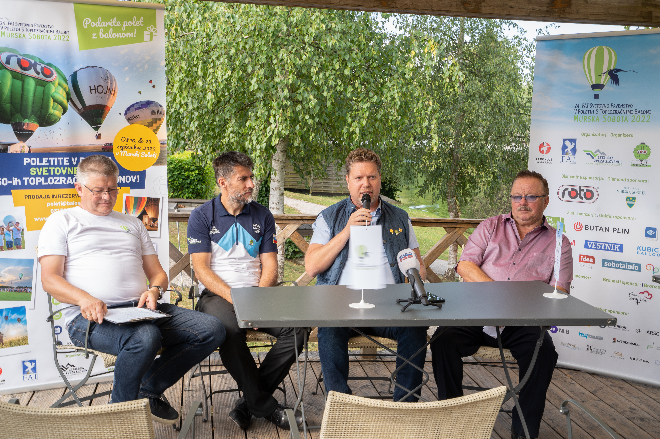
From left to right: Goran Grgič, Deputy Director of the World Championship, Igor Eržen, President of the Aeronautical Association of Slovenia, Matjaž Pavlinjek, President of the Roto Ballooning Club and Director General of the World Championship Organisation, Štefan Pavlinjek, President of the World Championship Organising Committee.

About hot air ballooning
Hot air ballooning is an attractive, yet highly specific and challenging competitive sport discipline that is also a feast for the eyes. It is popular in Slovenia and has a long tradition. The famous mathematician Jurij Vega was the first Slovenian to see a balloon in Vienna in 1784 and to write about it in his works The first stratospheric balloon seen in Slovenia landed in 1934 in Ženavlje in the Prekmurje region, a monument there commemorates the event. The beginnings of modern ballooning in Slovenia date back to 1978, when the first balloon with Avi Šorn in the basket flew into the sky.

Further information
Website: www.hotairballoons2022.com
Facebook and Instagram: hotairballoons2022
Hashtag: #hab2022

